**Art Detective: Sunday Afternoon on the Island of La Grande Jatte by Georges Seurat**

Supplies: pencils, crayons, colored pencils, and/or pen, (paint and paintbrushes if you have them) and paper (any size).

Today we are going to do an activity to help sharpen and develop your critical thinking skills, when looking at a piece of artwork.  It is time to play Art Detective!

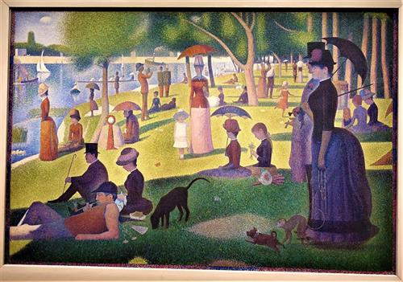

**Part one:** Study the painting and simply write a few words for each question on a sheet of paper.

*What do you see?

*What do you think is happening in this piece of art?

*What materials do you think the artist used in the piece of art?

*Does this piece of art remind you of anything?

*What kind of questions do you have about this piece of art?

*Pretend you can go inside this piece of art.  What sounds do you hear?  What do you smell?

*What part of the piece of art is your favorite?  Why?

*If you could change anything in this piece of art, what would you change?

*How does this piece of art make you feel?  Why?

*If you had to describe this piece of art to a friend, what kinds of words would you use?

**Part two:**On the back of your paper, draw, sketch, paint your own version of the painting **Sunday Afternoon on the Island of La Grande Jatte by Georges Seurat.**Recreate this painting and include your own family, pets, etc.  It can be at your favorite park, include what you see at your park and be CREATIVE!